Interpretable Rules for Rare Build-Up Failures in Football: Sequential Pattern Mining Meets Inductive Logic Programming
Moein Hassanpour
Department of Computer Engineering
Shahrood University of Technology, Shahrood, Iran
moein.hp@outlook.com
Abstract— Rare but costly build-up failures are difficult to detect in routine video review because each configuration may occur only a few times in a season. We present a leakage-controlled hybrid method that converts StatsBomb event and 360 data into Prolog facts, mines gap-constrained ordered patterns within each training fold, and uses Popper inductive logic programming with minimum description length (MDL) to learn short, auditable rules for sequences ending in an unrecovered loss of possession in a team’s own half. Five methodological safeguards and human review of every rule are integral to the design. On Barcelona 2020/21 and Bayer Leverkusen 2023/24, the hybrid reaches 25.3% precision against a 13.4% base rate for Barcelona (lift 1.89; reported confidence interval above 1) and is comparable to the baselines. For Leverkusen, lift is 1.26 and no method is a stable winner. Recall is deliberately low (5–17%). An AFC-certified coach approved 7 of 12 reviewed rules, including four conditionally. An aggregate risk model has held-out AUCs of 0.566 and 0.556. The system is a hypothesis generator for video review, not a predictor; absence of full tracking limits accuracy.
Keywords— football build-up, inductive logic programming, sequential pattern mining, interpretability, StatsBomb 360

1. Introduction
Losing possession in one’s own half during build-up is a particularly concerning moment for coaches: defenders have little time to reorganize and the opponent is close to goal. The number of players behind the ball has been reported as an important factor in counterattacks after a turnover [2]. Frequent patterns are familiar to coaches, but rare multi-action configurations—a two- or three-action sequence seen only a few times in a season—can escape both memory and routine video review, even though one occurrence may lead to a goal.
Common approaches assign numerical value to each action or use black-box models that require many examples. We study a different regime: one team, one season, and only about 175–177 negative examples, using free data and an output that can be read and audited. Inductive logic programming (ILP) can learn readable logic programs from limited data [4], but direct search over action sequences is combinatorial. We convert gap-constrained sequential patterns into predicates and ask Popper to select a compact subset. To our knowledge, this combination has not previously been reported for build-up failures. We make no claim of predictive or causal superiority.
Our contributions are: (1) a leakage-controlled hybrid pipeline with five safeguards (Fig. 1); (2) a two-team-season evaluation against the miner alone, Popper without mined patterns, and CART; (3) modular background knowledge that analysts can activate or filter without changing the learner; and (4) coach review that also records insights from rejected rules. We ask: RQ1, do concise rules exceed the outcome base rate out of fold? RQ2, do both hybrid components add value? RQ3, which rules does a coach find meaningful and actionable?

2. Related Work
Action valuation. VAEP measures changes in scoring probability over the next actions [7], while expected threat (xT) values ball movement between pitch zones [20]; xT values only progressive actions [23]. These methods provide numerical scores but do not describe the configuration in which a sequence breaks down. Following Rudin [19], we prefer an intrinsically interpretable model.
Tactics and defensive transitions. Decroos et al. [8] discover attacking tactics by clustering phases. Biermann et al. [2] predict counterattacks with logistic regression over comprehensible features. Dash et al. [6] study 2,413 defensive transitions by Barcelona and Real Madrid using spatial indicators and gradient boosting on tracking data. These outputs are clusters, weights, or scores rather than logic rules. Our spatial layer relies on 360 frames that record only players in view [21].
ILP in sport. ILP learns logic theories from examples and background knowledge [16]. Popper prunes the hypothesis space by learning from failures [5], uses Clingo for solving [10], and supports MDL programs for noisy data [11]. In sport, Vercruyssen et al. [24] combine qualitative spatial reasoning and ILP for pass prediction, Van Haaren et al. [22] discover attacking patterns with ILP, and Jacobs et al. [12] use ILP to verify agent behavior in RoboCup. None targets build-up failure.
Sequential patterns and evaluation. Emerging patterns are itemsets whose support rises sharply between classes [9], making growth rate a natural criterion for patterns that distinguish failed sequences. PrefixSpan [17] and gap-constrained generalizations [1] grow patterns through projected prefixes. Data leakage can produce optimistic results [13], while random cross-validation underestimates error for dependent data [18]; we therefore split by match.

3. Data and Problem Definition
We use StatsBomb Open Data events, line-ups, and 360 frames for two team-seasons (Table I). Coordinates are converted to SPADL dimensions (105 × 68 m), with the focal team always attacking toward positive x. A 360 frame records only visible players and does not provide identities for non-actors; continuous tracking is unavailable.
TABLE I. DATASET
Measure | Barcelona 20/21 | Leverkusen 23/24
Matches with 360 data | 35 | 31 of 34
Build-up sequences | 1,308 | 1,086
Negative / non-negative | 175 / 1,133 | 177 / 909
Base rate π | 13.38% | 16.30%
360 frame coverage | 92.7% | 85.8%
Sequence construction. Each sequence starts at the first focal-team action in a possession chain in the team’s own half ($x≤52.5 m$), with at most one sequence per possession. Sequences starting from throw-ins, corners, or free kicks are excluded, except short or medium goal-kick build-ups. A sequence ends at the first shot, failed action, controlled entry into the attacking region (deep quarter, zone 14, or deep half-space; for a pass, a same-region receipt must confirm entry), 25-action cap, or end of possession. We retain $2≤n≤25$ actions (median length: 8). For $S=\left(a_{1},…,a_{n}\right)$, the learner sees only prefix $\left(a_{1},…,a_{n-1}\right)$:
 | $$\begin{matrix}y\left(S\right)=1⇔​ & x_{loss}\left(S\right)≤52.5 \\ & ∧ ¬ {Rec}_{5}\left(S\right) ∧ ¬ Foul\left(S\right)\end{matrix}$$ | (1)
Here $x_{loss}$ is the turnover location, ${Rec}_{5}$ denotes controlled recovery within five seconds, and Foul denotes a foul as the opponent’s first action (an ambiguous boundary case). A non-negative sequence does not necessarily indicate tactical success. The base rate is $π=\left|\{S:y\left(S\right)=1\}\right| / \left|D\right|$.
Control sampling. For Popper and CART training, we select at most $r=2$ context-matched controls per negative, matched on start zone, pressure, and sequence length. The miner uses all training sequences at natural prevalence, and evaluation always uses all sequences from held-out matches at natural prevalence. With $P$ negatives, $N_{0}$ non-negatives, and sampling fraction $s=rP/N_{0}$, natural-prevalence precision can be approximated from sampled confidence $c$ as:
 | $${Prec}_{nat}≈\frac{c}{c+\left(1-c\right)/s}$$ | (2)
For Barcelona, $s=0.309$; for Leverkusen, $s=0.389$. For example, $c=0.6$ corresponds to approximately 0.32 and 0.37, respectively. Sampled confidence is therefore not directly comparable to natural-prevalence rates.
Data limitations. Off-ball movement and speed are unavailable. Predicates that depend on the terminal action (and could leak the label), as well as concepts that could not be defined precisely with these data, were excluded. Predicates such as rest_defence_exposed are proxies for defensive shape, not direct measurements.

4. Method
The five-stage pipeline (Fig. 1) converts data to Prolog facts, defines background knowledge (BK), mines sequential patterns, learns rules with Popper, and sends every candidate for coach review. Facts contain no labels; labels enter only during learning.
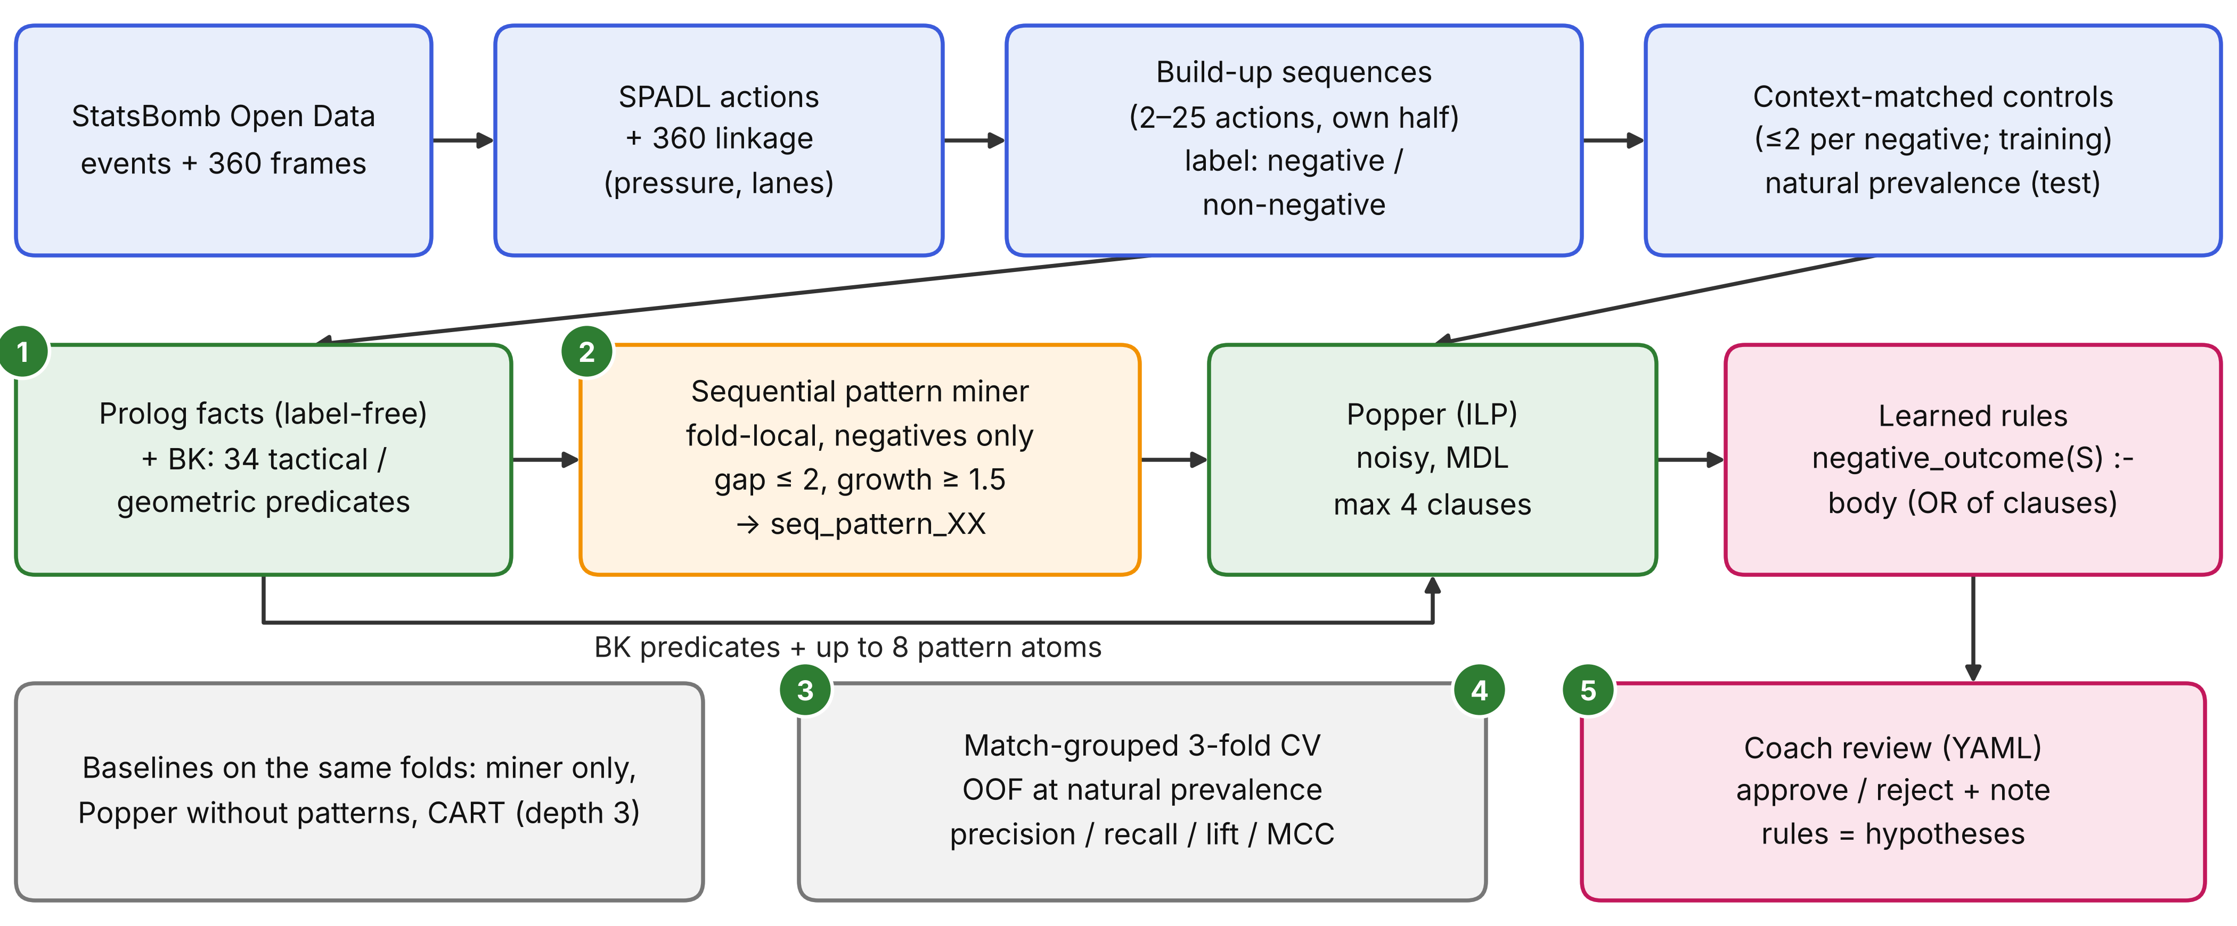
Fig. 1. Five safeguards: (1) unlabeled facts; (2) pattern mining inside each fold; (3) match-grouped folds; (4) natural-prevalence evaluation; and (5) human review of every rule.

4.1 Background Knowledge
Tactical and geometric concepts are declarative Prolog rules over base facts (SWI-Prolog [25]). The pitch is divided into three thirds (defensive $x≤35$, middle, attacking) and five lanes, aggregated into left/centre/right channels for mining. Pressure means at least one opponent within 5 m; an open passing lane means a teammate is reachable with no opponent within 2 m of the lane. Each sequence-level predicate is an existential wrapper over the prefix: $seq_X\left(S\right)⇔∃ j≤n-1: X\left(a_{j}\right)$. The active vocabulary contains 34 predicates. This is propositionalization [14]: relational concepts may be multi-ary in BK, but the hypothesis learner sees unary sequence-level features to constrain combinatorial growth. It therefore does not directly learn multi-player relations. Table II defines predicates appearing in Table IV.
TABLE II. OPERATIONAL DEFINITIONS OF PREDICATES IN TABLE IV
Predicate | Operational definition and caveat
under_pressure | At least one opponent within 5 m (weakest pressure threshold).
rest_defence_exposed | Fewer than two non-goalkeeper teammates ≥5 m behind the carrier; a proxy (in the defensive third, partly reflects the ball being with the deepest player).
dead_end_support | Valid frame and no teammate with an open passing lane.
line_pass | Successful pass from a non-central lane to the same lane, non-lateral direction; includes backward passes and is not necessarily longitudinal.
connecting_pass | Successful short pass (<10 m) that is non-progressive.
first_time_play | Possession duration ≤0.5 s; a temporal proxy.
fast_sequence | Actions per second ≥70th percentile.
flank_backward_carry | Carry from a flank to the same flank with $Δx≤-4 m$.

4.2 Sequential Pattern Mining
Each item is a tuple (predicate, action type, channel, pitch third), and $M\left(a\right)$ is the set of items for action a. A pattern $p=\left(ι_{1},…,ι_{k}\right)$, with $k∈\{2,3\}$ and maximum gap $g=2$ [1], matches sequence S if:
 | $$\begin{matrix}S⊨p⇔​ & ∃ t_{1}<…<t_{k}≤n-1: ∀j≤k, ι_{j}∈M\left(a_{t_{j}}\right) \\ & ∧ ∀j<k, 0≤t_{j+1}-t_{j}-1≤g\end{matrix}$$ | (3)
Patterns are mined only from negative training examples within each fold (closed patterns with respect to support under the stated search bounds), then counted on non-negative training examples. The terminal action is removed before mining. Predicates that inspect the following action (e.g., line_pass and first_time_play) are masked on the last retained action. To reduce confounding by context composition (start location, pressure, and length category), rates are standardized over strata $S$ shared by the negative and non-negative classes. Let $T_{s}$ and $C_{s}$ be the negative and non-negative training examples in stratum $s$, ws=Ts /s'​Ts', and $α=0.5$:
 | rTp=s∈S​ws supTsp+αTs+2αrCp=s∈S​ws supCsp+αCs+2αGRp=rTprCp | (4)
A pattern is accepted when it matches at least five negative sequences and $GR≥1.5$ [9]; this is a training-set ranking criterion, not a significance test. Accepted patterns are sorted by GR, then negative support, then shorter length. Up to the top eight become seq_pattern_XX(S), expressing only whether the ordered pattern occurs in the prefix. Our miner is a bounded, prefix-based, gap-constrained, support-closed variant, not a canonical implementation of Gap-BIDE [15].

4.3 Popper Learning
In its noisy setting, Popper searches for a program with minimum MDL cost:
 | $$cost\left(h\right)=size\left(h\right)+FN\left(h\right)+FP\left(h\right)$$ | (5)
Here size counts literals and $FN/FP$ are training errors. A single-atom clause has size 2 and reduces cost only if it adds at least three net true positives, consistent with low_support=3. Settings: target negative_outcome(S); at most two variables, three body literals, and four clauses (logical OR); BK with 34 predicates and at most eight pattern atoms; 600 seconds per fold. With 42 predicates, the unconstrained program space has an upper bound of roughly ${10}^{15}$, motivating clause and time limits. A timeout or NO SOLUTION is not counted as success.

4.4 Arms and Evaluation Protocol
Four arms use the same folds and test population: hybrid (34 predicates plus up to eight pattern atoms, with Popper clauses combined by OR); miner only (OR over the same mined patterns, ablating Popper); Popper without patterns (ablating the miner); and CART (Gini, $depth≤3$, at least 10 samples per leaf; [3]). Popper and CART train on matched controls, while the miner trains at natural prevalence. Comparisons therefore concern complete procedures, not isolated algorithm effects.
We use three-fold cross-validation grouped by match with a fixed seed. Predictions are aggregated out of fold (OOF) across all test sequences at natural prevalence:
 | $$P=\frac{TP}{TP+FP}, R=\frac{TP}{TP+FN}, Lift=\frac{P}{π}$$ | (6)
We also report each rule’s seasonal rate: $h\left(p\right)$ is the number of negative matches and $cov\left(p\right)$ is the total number of matching sequences.
 | $$ρ\left(p\right)=\frac{h\left(p\right)}{cov\left(p\right)}$$ | (7)
Coach review. For each rule, support, confidence, and lift are calculated on a fixed 75/25 match split. We flag low_support (support<3) and a confidence decline exceeding 50% from training to holdout. An AFC-certified coach, without blinding, marks each rule approved or rejected and records notes. Holdout scores also inform candidate ranking, so this is not an independent estimate.

5. Results

5.1 Arm Comparison
Table III reports the primary OOF comparison at natural prevalence. The methods share the same folds, sequences, and test labels (verified by SHA-256 for each fold).
For Barcelona, the hybrid reaches precision 0.253 (lift 1.89) and the best MCC. Miner only (lift 2.03) and CART (1.44) also exceed the base rate; the reported lift confidence intervals for all three are above 1. For Leverkusen, intervals for the hybrid, miner, and CART include 1, while pattern-free Popper reaches lift 1.73 with precision CI 20–38% [26]. With three folds and no significance test, differences are inconclusive; no method wins in both team-seasons. Recall is deliberately low (5–17%): outputs are hypotheses, not comprehensive coverage.

5.2 Discovered Rules
The final Barcelona hybrid has four clauses (four sequential patterns), and the Leverkusen hybrid has three; in effect, each is an OR over unary pattern atoms. Multi-condition combinations such as B6 are intermediate cross-validation candidates, not clauses in the final program. Table IV shows six representative rules among the 12 reviewed. Rates are in-sample and the rules were selected partly for high rates, so they are optimistic.

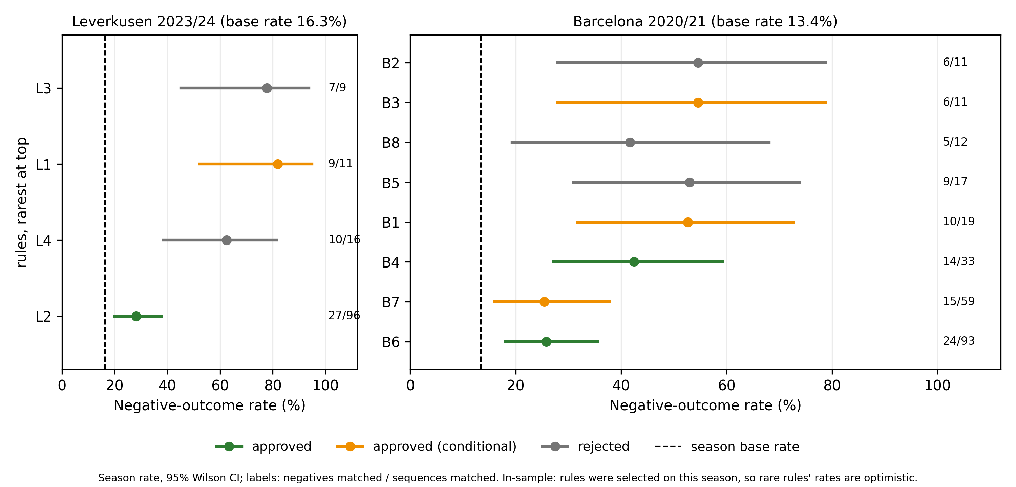
Fig. 2. Seasonal in-sample negative-outcome rates for the reviewed rules in Barcelona and Leverkusen. These selected-rule rates are descriptive and optimistic; they are not OOF arm-level lift estimates.
TABLE III. THREE-FOLD OOF RESULTS AT NATURAL PREVALENCE
Team | Method | TP | Prec. | Recall | Lift | MCC
Barcelona | Hybrid | 25 | 0.253 | 0.143 | 1.89 | 0.100
Barcelona | Miner only | 16 | 0.271 | 0.091 | 2.03 | 0.088
Barcelona | CART | 30 | 0.192 | 0.171 | 1.44 | 0.063
Barcelona | Popper, no patterns | NO SOLUTION | — | — | — | —
Leverkusen | Hybrid | 17 | 0.205 | 0.096 | 1.26 | 0.033
Leverkusen | Miner only | 10 | 0.222 | 0.056 | 1.36 | 0.033
Leverkusen | CART | 14 | 0.255 | 0.079 | 1.56 | 0.057
Leverkusen | Popper, no patterns | 27† | 0.281† | 0.153† | 1.73† | 0.100†
† The same pattern-free Popper program (seq_flank_backward_carry) was found in all three folds; metrics are for that rule over all sequences (27 negative outcomes among 96 matching sequences).

Pattern-free ablation. In Barcelona, Popper without patterns ended with NO SOLUTION without timing out, whereas Popper with mined patterns found a program; this is direct evidence that patterns reduced the search burden in this run. In Leverkusen, the pattern-free arm found the same single-clause program in all folds, the hybrid retained the same atom, and all three CART trees had a root from the same family. This predicate covers both flanks without distinguishing left from right. Three methods thus selected a generic atom, consistent with a general weakness in backward flank carries (separate left/right counts were not reported).
Rule notation. Each step is predicate(action, channel L/C/R, third D/M); arrows indicate order with a maximum gap of two actions, while “+” denotes unordered sequence-level features. B6 is an intermediate CV candidate. Rules with lifts around 3–5 have coverage of 33 or less and wide confidence intervals. More frequent rules (L2, B4, B6) are estimated more precisely but have lower lift. The apparent association between rarity and high rate is partly a selection effect.
TABLE IV. REPRESENTATIVE RULES, IN-SAMPLE SEASONAL RATES, AND COACH DECISIONS
Rule | Ordered pattern | Support; rate (95% CI) | Lift; decision
L1 | under_pressure(carry,R,D) → dead_end_support(carry,R,D) | 9/11; 81.8% (52–95) | 5.02; Conditional
L2 | flank_backward_carry (single atom) | 27/96; 28.1% (20–38) | 1.73; Approved
L3 | line_pass(pass,R,D) → connecting_pass(pass,R,D) → rest_defence_exposed(carry,R,D) | 7/9; 77.8% (45–94) | 4.77; Rejected
B1 | rest_defence_exposed(pass,C,D) → rest_defence_exposed(pass,L,D) → under_pressure(carry,L,M) | 10/19; 52.6% (32–73) | 3.93; Conditional
B4 | line_pass(pass,R,D) → first_time_play(pass,R,D) | 14/33; 42.4% (27–59) | 3.17; Approved
B6 | line_pass + first_time_play + fast_sequence | 24/93; 25.8% (18–36) | 1.93; Approved

5.3 Coach Review and Aggregate Risk Model
The coach approved five of eight Barcelona rules (three conditional) and two of four Leverkusen rules (one conditional), for 7 of 12 overall. Rejections mostly reflected limited evidence (few occurrences or zero to two holdout examples), not tactical incorrectness. The coach also retained observations from rejected rules: Leverkusen patterns were concentrated in the right channel, Barcelona patterns in the left. These are interpretations consistent with the patterns, not independent confirmation; rules can share steps and sequences (e.g., L3 and L4 share their first two steps). Further readings—high pressure, body orientation toward the line, or player identity—are expert interpretations.
An aggregate risk model (L1 logistic regression over indicators for approved rules) discriminates weakly on holdout: AUC 0.566 (333 sequences) and 0.556 (273 sequences). Large odds ratios (e.g., 19.3 for Leverkusen L1, based on 11 occurrences) are unstable. This agrees with low recall; the holdout was not completely untouched.

6. Discussion and Limitations
What is shown. In a low-data regime, the pipeline produces short, auditable rules that reach 1.4–2.0 times the base rate out of fold at natural prevalence for Barcelona and are meaningful to a coach; the Leverkusen result is inconclusive. The intended use is hypothesis generation for video review (AUC around 0.56, recall below 18%).
Component value. The miner contributes temporal order and reduces Popper’s search burden (the Barcelona no-pattern run found no solution); Popper uses MDL to choose a compact subset; Prolog BK keeps concepts declarative and editable. The hybrid is comparable to baselines in enrichment and has no stable superiority; in Leverkusen, patterns added little over a simple rule. CART also uses the same Prolog feature layer, so its comparison measures logical search rather than the value of Prolog itself. The event that breaks a sequence may not be the event named by its pattern.
Limitations. (1) Each study covers one team in one season, so we make no generalization claim. (2) Three folds without significance tests or match-clustered intervals provide descriptive evidence only. (3) Rules are selected from many candidates, rates are in-sample, and match-level permutation tests and simple baselines (sequence length, start location) were not run. (4) The outcome is operationally defined, and match-grouped CV does not remove dependence among sequences within a match. (5) 360 frames are incomplete and do not support off-ball concepts.

7. Conclusion and Future Work
We showed that sequential pattern mining, Prolog background knowledge, and Popper can extract short, auditable rules for build-up failures in a very low-data regime, for coach review, with safeguards against leakage and optimism. Barcelona showed out-of-fold enrichment; Leverkusen was inconclusive. The hybrid was comparable to baselines and recall was low. The system is a hypothesis-generation tool.
Future work. (1) Focused runs with coach-configured BK, such as goalkeeper predicates or a single region. (2) Reverse application to recent opponent matches to find fragile build-up patterns; the hypothesis that creating several conditions together increases opponent failure remains untested. (3) Full tracking and player identities may improve off-ball predicates, an expectation not yet tested; richer vocabularies also expand search and reduce support per rule.

References
[1] Antunes, C., and Oliveira, A. L. (2003). Generalization of pattern-growth methods for sequential pattern mining with gap constraints. In Machine Learning and Data Mining in Pattern Recognition, LNCS 2734. Springer. doi:10.1007/3-540-45065-3_21
[2] Biermann, H., Wieland, F.-G., Timmer, J., Memmert, D., and Phatak, A. (2023). Towards expected counter—Using comprehensible features to predict counterattacks. Communications in Computer and Information Science, 1783, 3–13. doi:10.1007/978-3-031-27527-2_1
[3] Breiman, L., Friedman, J. H., Olshen, R. A., and Stone, C. J. (1984). Classification and Regression Trees. Wadsworth.
[4] Cropper, A., and Dumančić, S. (2022). Inductive Logic Programming at 30: A New Introduction. Journal of Artificial Intelligence Research, 74, 765–850. doi:10.1613/JAIR.1.13507
[5] Cropper, A., and Morel, R. (2021). Learning programs by learning from failures. Machine Learning, 110(4), 801–856. doi:10.1007/s10994-020-05934-z
[6] Dash, S., Ide, K., Umemoto, R., Amino, K., and Fujii, K. (2025). Prediction-based evaluation of back-four defense with spatial control in soccer. arXiv:2511.06191 (preprint).
[7] Decroos, T., Bransen, L., Van Haaren, J., and Davis, J. (2019). Actions speak louder than goals: Valuing player actions in soccer. Proceedings of KDD, 1851–1861. doi:10.1145/3292500.3330758
[8] Decroos, T., Van Haaren, J., and Davis, J. (2018). Automatic discovery of tactics in spatio-temporal soccer match data. Proceedings of KDD, 223–232. doi:10.1145/3219819.3219832
[9] Dong, G., and Li, J. (1999). Efficient mining of emerging patterns: Discovering trends and differences. Proceedings of KDD, 43–52.
[10] Gebser, M., Kaminski, R., Kaufmann, B., and Schaub, T. (2019). Multi-shot ASP solving with clingo. Theory and Practice of Logic Programming, 19(1), 27–82.
[11] Hocquette, C., Niskanen, A., Järvisalo, M., and Cropper, A. (2024). Learning MDL logic programs from noisy data. Proceedings of AAAI, 38(9), 10553–10561. doi:10.1609/aaai.v38i9.28925
[12] Jacobs, N., Driessens, K., and De Raedt, L. (1998). Using ILP-systems for verification and validation of multi-agent systems. In Inductive Logic Programming, LNCS 1446. Springer. doi:10.1007/BFb0027318
[13] Kapoor, S., and Narayanan, A. (2023). Leakage and the reproducibility crisis in machine-learning-based science. Patterns, 4(9), 100804. doi:10.1016/j.patter.2023.100804
[14] Kramer, S., Lavrač, N., and Flach, P. (2001). Propositionalization approaches to relational data mining. In Relational Data Mining, 262–291. Springer.
[15] Li, C., Yang, Q., Wang, J., and Li, M. (2012). Efficient mining of gap-constrained subsequences and its various applications. ACM Transactions on Knowledge Discovery from Data, 6(1). doi:10.1145/2133360.2133362
[16] Muggleton, S., and De Raedt, L. (1994). Inductive logic programming: Theory and methods. The Journal of Logic Programming, 19–20, 629–679.
[17] Pei, J., Han, J., Mortazavi-Asl, B., Pinto, H., Chen, Q., Dayal, U., and Hsu, M.-C. (2001). PrefixSpan: Mining sequential patterns efficiently by prefix-projected pattern growth. Proceedings of ICDE, 215–224.
[18] Roberts, D. R., Bahn, V., Ciuti, S., Boyce, M. S., Elith, J., Guillera-Arroita, G., et al. (2017). Cross-validation strategies for data with temporal, spatial, hierarchical, or phylogenetic structure. Ecography, 40(8), 913–929. doi:10.1111/ecog.02881
[19] Rudin, C. (2019). Stop explaining black box machine learning models for high stakes decisions and use interpretable models instead. Nature Machine Intelligence, 1(5), 206–215. doi:10.1038/s42256-019-0048-x
[20] Singh, K. (2019). Introducing expected threat (xT). Blog post. https://karun.in/blog/expected-threat.html
[21] StatsBomb. (2021). StatsBomb announce the release of free StatsBomb 360 data: Euro 2020 available now. Blog post.
[22] Van Haaren, J., Dzyuba, V., Hannosset, S., and Davis, J. (2015). Automatically discovering offensive patterns in soccer match data. Advances in Intelligent Data Analysis XIV, LNCS 9385, 286–297. doi:10.1007/978-3-319-24465-5_25
[23] Van Roy, M., Robberechts, P., Decroos, T., and Davis, J. (2020). Valuing on-the-ball actions in soccer: A critical comparison of xT and VAEP. Proceedings of the AAAI-20 Workshop on AI in Team Sports, 1–8.
[24] Vercruyssen, V., De Raedt, L., and Davis, J. (2016). Qualitative spatial reasoning for soccer pass prediction. Proceedings of the 3rd Workshop on Machine Learning and Data Mining for Sports Analytics, CEUR Workshop Proceedings, vol. 1842 (ECML/PKDD 2016).
[25] Wielemaker, J., Schrijvers, T., Triska, M., and Lager, T. (2012). SWI-Prolog. Theory and Practice of Logic Programming, 12(1–2), 67–96. doi:10.1017/S1471068411000494
[26] Wilson, E. B. (1927). Probable inference, the law of succession, and statistical inference. Journal of the American Statistical Association, 22(158), 209–212. doi:10.1080/01621459.1927.10502953

